**ASSIGNMENT 3**

**Prepare R&D Document on Azure Global Infrastructure such as Geographies, Azure Regions, Availability Zones, Data Centres.**

1. **Azure Global Infrastructure:**

* **Overview of Cloud Computing**

Cloud computing is a paradigm that allows users to access and store data and applications over the internet rather than relying on local servers or personal computers. This model offers several advantages, including scalability, flexibility, and cost-effectiveness. Organizations can quickly scale resources up or down based on demand, reducing the need for significant capital investment in hardware. Additionally, cloud computing enables remote work and collaboration, allowing teams to access applications and data from anywhere in the world. The significance of cloud computing in modern IT is underscored by its ability to drive innovation, enhance operational efficiency, and support the rapid deployment of new services.

* **Microsoft Azure**

Microsoft Azure is a comprehensive cloud computing platform that provides a wide array of services, including computing power, analytics, storage, and networking. As one of the leading cloud service providers, Azure supports various programming languages, frameworks, and tools, making it a versatile choice for developers and businesses alike. Azure's role in digital transformation is pivotal, as it enables organizations to modernize their IT infrastructure, adopt new technologies, and leverage data analytics to gain insights and drive decision-making. With its extensive service offerings, Azure empowers businesses to innovate and respond to market changes swiftly.

The purpose of this document is to explore Azure's global infrastructure in detail, covering its geographies, regions, availability zones, data centers, compliance standards, and future developments. By providing a comprehensive overview, this document aims to inform stakeholders about how Azure's infrastructure supports business operations, enhances service delivery, and ensures compliance with regulatory requirements.

1. **Geographies**

In the context of Azure, geographies refer to distinct geographic areas that contain one or more regions. Each geography is designed to meet specific compliance and data residency requirements, ensuring that data is stored and processed in accordance with local laws and regulations. Geographies are critical for organizations that operate in multiple countries, as they allow businesses to choose where their data is stored based on legal and regulatory considerations.

* **Purpose of Geographies**

Geographies serve several important purposes:

* Data Residency: Organizations can select specific geographies to store their data, ensuring compliance with local data protection laws and regulations. This is particularly important for industries such as finance and healthcare, where data residency is a legal requirement.
* Compliance: Different geographies adhere to various compliance standards, allowing businesses to meet legal and regulatory requirements specific to their industry and location. For example, the General Data Protection Regulation (GDPR) in Europe imposes strict rules on data handling and processing.
* Latency: By having data centers located closer to users, Azure can provide lower latency and improved performance for applications. This is crucial for businesses that require real-time data access and processing.
* **List of Azure Geographies**
* North America: Includes regions in the United States and Canada, providing services that comply with North American regulations.
* Europe: Comprises multiple regions across various European countries, ensuring compliance with GDPR and other local laws.
* Asia Pacific: Encompasses regions in countries like Australia, Japan, and Singapore, catering to the growing demand for cloud services in the Asia-Pacific region.
* Middle East: Focuses on providing services to businesses in the Middle East, with compliance to local regulations.
* Africa: Expanding Azure's presence in Africa to support local businesses and comply with regional data protection laws.

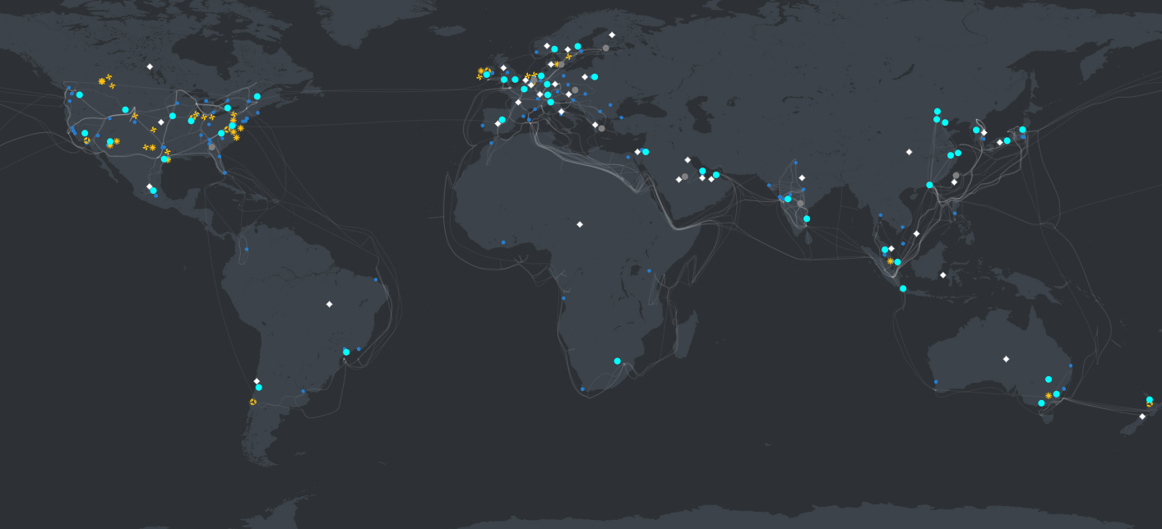

* **Compliance Standards**

Azure geographies comply with various standards, such as:

* GDPR: Ensures that organizations operating in Europe can meet strict data protection requirements.
* ISO 27001: An international standard for information security management systems, demonstrating Azure's commitment to data security.
* HIPAA: Compliance with the Health Insurance Portability and Accountability Act for organizations in the healthcare sector.

1. **Azure Regions**

An Azure region is a set of data centers deployed within a specific geographic area. Each region is designed to provide high availability and redundancy, allowing businesses to deploy applications and services with confidence. Regions are interconnected through a high-speed network, enabling seamless data transfer and communication between them.

As of now, Azure operates in over 60 regions worldwide, making it one of the most extensive cloud infrastructures available. This global reach allows organizations to deploy applications closer to their users, enhancing performance and reliability. The distribution of regions also enables businesses to comply with local data residency requirements while benefiting from Azure's robust cloud services.

* **Features of Regions**
* High-speed Connectivity: Azure regions are interconnected with high-speed networks, ensuring fast data transfer and communication. This connectivity is essential for applications that require real-time data access and processing.
* Low-latency Access: Proximity to users reduces latency, improving the performance of applications hosted in Azure. This is particularly important for applications that require quick response times, such as online gaming or financial trading platforms.
* Regional Services Availability: Each region offers a variety of services tailored to meet local demands and compliance requirements. This includes services like Azure Virtual Machines, Azure SQL Database, and Azure Kubernetes Service.
* **Examples of Regions**
* East US: A major region that offers a wide range of services and is strategically located to serve the eastern United States.
* West Europe: A key region for businesses operating in Europe, providing compliance with GDPR and other local regulations.
* Southeast Asia: A rapidly growing region that caters to the increasing demand for cloud services in Southeast Asia.

1. **Availability Zones**

Availability zones are unique physical locations within an Azure region, designed to protect applications and data from datacenter failures. Each zone is a separate entity with its own power, cooling, and networking, ensuring that a failure in one zone does not affect the others.

**Importance of High Availability**

Availability zones are critical for ensuring high availability. By distributing resources across multiple zones, organizations can maintain service continuity even in the event of a failure in one zone. This architecture is essential for mission-critical applications that require 99.99% uptime.

**Configuration of Availability Zones**

Each availability zone is equipped with independent power, cooling, and networking, ensuring that a failure in one zone does not affect the others. This configuration allows for robust disaster recovery and business continuity strategies. Organizations can deploy applications across multiple zones to achieve redundancy and fault tolerance.

**Examples of Regions with Availability Zones**

* West US: This region has multiple availability zones, allowing businesses to deploy applications with high availability.
* East US: Offers several availability zones to ensure that applications remain operational even in the event of a failure.
* UK South: Provides availability zones to support businesses in the UK, ensuring compliance with local regulations while maintaining high availability.

1. **Data Centers**

Azure data centers are the backbone of the cloud infrastructure, housing the physical servers and storage systems that power Azure services. They are strategically located to provide redundancy and high availability, ensuring that services remain operational even in the event of a failure.

**Security Measures**

Azure employs a range of physical and operational security measures to protect its data centers, including:

* Biometric Access Controls: Restricted access to data centers using biometric authentication, ensuring that only authorized personnel can enter.
* Surveillance: Continuous monitoring through advanced surveillance systems to ensure security. This includes both physical security measures and cybersecurity protocols to protect against unauthorized access.
* Fire Suppression Systems: Advanced fire suppression systems are in place to protect equipment and data from fire hazards.

**Sustainability Practices**

Azure is committed to sustainability, implementing energy-efficient designs and utilizing renewable energy sources. This commitment not only reduces the carbon footprint but also aligns with global sustainability goals. Microsoft has pledged to be carbon negative by 2030, and Azure's data centers play a crucial role in achieving this goal.

**Global Distribution**

Azure has a vast network of data centers distributed across various geographies, ensuring that organizations can choose locations that meet their specific needs for performance and compliance. This global distribution allows businesses to deploy applications closer to their users, enhancing performance and reducing latency.

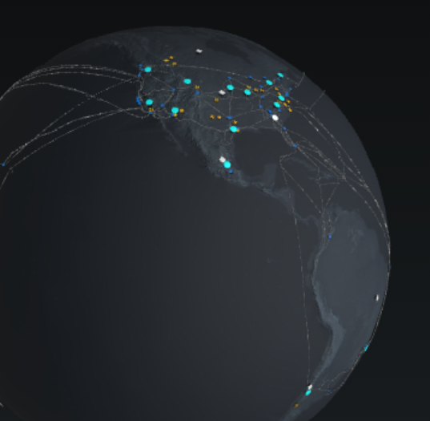

1. **Region Pairs**

Region pairs are two Azure regions that are located at least 300 miles apart. Each region pair is designed to provide disaster recovery and data redundancy, ensuring that organizations can maintain operations even in the event of a regional outage.

**Disaster Recovery**

Region pairs facilitate disaster recovery by allowing organizations to replicate data and applications across regions. In the event of a failure in one region, services can be quickly restored from the paired region. This architecture is essential for businesses that require high availability and minimal downtime.

**Geographic Separation**

The geographic separation of region pairs minimizes the risk of simultaneous outages due to natural disasters or other events, ensuring that businesses can maintain operations even in adverse conditions. This separation is particularly important for organizations that operate in regions prone to natural disasters, such as hurricanes or earthquakes.

**Examples of Region Pairs**

* West US and East US: These regions are paired to provide disaster recovery and data redundancy for businesses operating in the United States.
* North Europe and West Europe: This pairing allows organizations to replicate data and applications across regions while ensuring compliance with European regulations.

1. **Compliance and Security**

Compliance Certifications

Azure holds numerous compliance certifications, including:

* ISO 27001: An international standard for information security management systems, demonstrating Azure's commitment to data security.
* HIPAA: Compliance with the Health Insurance Portability and Accountability Act for organizations in the healthcare sector, ensuring that sensitive patient data is protected.
* SOC 1/2/3: Service Organization Control reports for security, availability, and confidentiality, providing assurance to customers about Azure's security practices.

**Data Protection Measures**

Azure employs various data protection measures, including:

* Encryption: Data is encrypted both at rest and in transit to protect against unauthorized access. Azure uses industry-standard encryption protocols to ensure data security.
* Threat Detection: Continuous monitoring and threat detection systems to identify and mitigate risks. Azure Security Center provides advanced threat protection and security management for Azure resources.
* Access Controls: Role-based access controls (RBAC) ensure that only authorized users can access sensitive data and applications.

Regulatory Compliance

Azure helps organizations meet regulatory requirements by providing tools and services that ensure compliance with local laws and regulations. This includes compliance with GDPR, HIPAA, and other industry-specific regulations, making it easier for businesses to operate in multiple jurisdictions.

Azure's global infrastructure is a critical component of its cloud services, providing businesses with the tools they need to operate efficiently and securely in a digital world. The extensive network of geographies, regions, availability zones, and data centers ensures that organizations can deploy applications with confidence.

Azure's infrastructure supports businesses in achieving their goals by offering scalable, reliable, and compliant cloud solutions that enhance operational efficiency and drive innovation. Organizations can leverage Azure's capabilities to improve their agility, reduce costs, and enhance customer experiences.

As cloud computing continues to evolve, Azure's role as a leading provider will be pivotal in shaping the future of technology and business operations. With ongoing investments in infrastructure and innovation, Azure is well-positioned to meet the demands of the digital age.